A Global Jazz Dialogue: A New Album Unites Voices from Seven Cultures
Dorota Piotrowska & Sound Circle release Voices of Human Consciousness

From Norwegian fjords to Arabic rhythms; Polish lyricism to the traditions of American jazz this album brings together talented musicians from different backgrounds who aren’t afraid to let improvised musical dialogue lead their work and break conventions.

Brought together by bandleader Dorota Piotrowska, this forthcoming album, Voices of Human Consciousness, features improvised compositions by Piotrowska, Greg Osby, Hildegunn Øiseth, Tarek Yamani and work from Ameen Saleem, Sanem Kalfa, Barbaro Crespo and Leszek Możdżer.

Recorded over three days in Poland, at 432 Hz, Piotrowska and her ensemble prove that powerful musical experiences are a reflection of the technical mastery and cultural richness of those involved. The international collective, from the USA, Poland, Lebanon, Cuba, Norway, and Turkey create a unique sonic space in which improvised music becomes a universal language of communication. This album is a double release with Inner Circle Music and Teraz Teraz.

“I had been waiting for the right moment to record this album for about a decade. This project is the musical mosaic I envisioned years ago,” said Piotrowska. “The compositions on the album represent the musical heritage of the musicians, centering dialogue that can be fostered through music. I hope people hear in the work something that can inspire and build bridges.”

Just ahead of UNESCO’s International Jazz Day, the group will premiere their work on 25 April 2026 at “Jazz nad Odrą Festival,” one of the oldest and most prestigious jazz festivals in Europe. This event will be a rare opportunity to experience the new material performed live for the first time

The digital release on Spotify, Apple Music and other streaming services is planned for
1 June 2026.
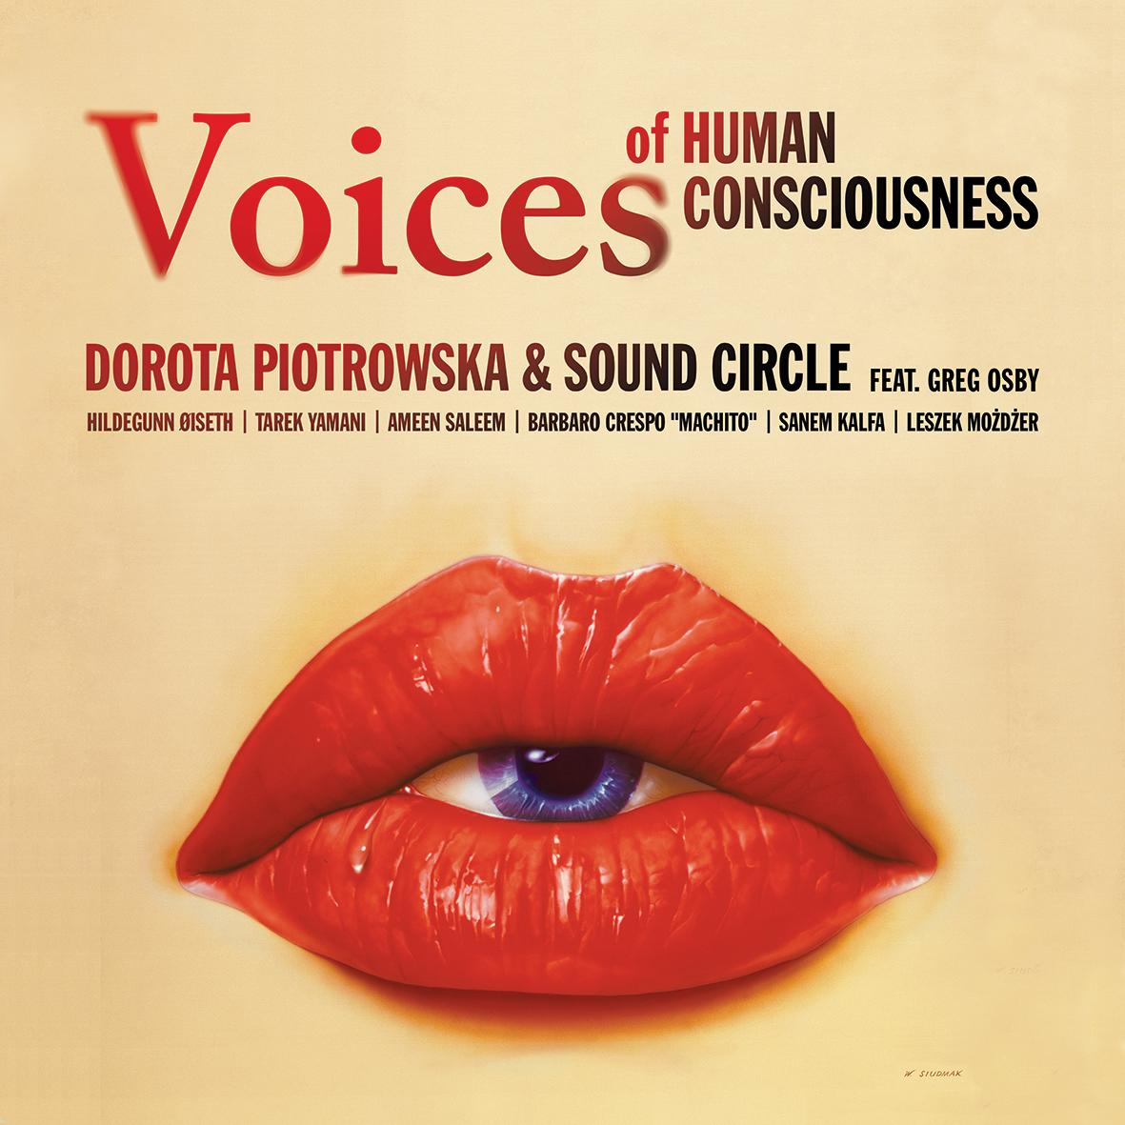
The album cover for Voices of Human Consciousness features artwork by Wojciech Siudmak, one of Poland’s most internationally acclaimed contemporary painters and a leading figure of fantastic realism.

For press inquiries, more information or pre-release listening material please contact dorums@gmail.com or +48 728306014.

Click here for a version in Google Doc.

Artist bios:

Dorota Piotrowska is a Polish jazz drummer and bandleader recognized as one of the most distinctive voices bridging the European and New York jazz scenes. Including eight formative years in New York, she has built an international career performing at major venues including Carnegie Hall, Lincoln Center, Konserthuset Stockholm, collaborating with leading artists such as Jeremy Pelt, Anthony Wonsey, the Curtis Brothers, Ceacilie Norby, Sisters in Jazz, Jan Lundgren and others. Piotrowska has appeared as a drummer and collaborator on eight albums, including Sisters in Jazz by Cæcilie Norby, recorded for ACT Music. A graduate of The New School for Jazz and Contemporary Music, she is the founder and artistic director of the New York Jazz Masters educational program.

At the center of the project is one of Piotrowska’s mentors and one of the most influential saxophonists in contemporary jazz — Greg Osby. Osby’s career spans nearly four decades at the forefront of modern jazz. Widely praised for his intellectually rigorous and forward-thinking approach to composition and improvisation, he has released over 25 albums as a leader, including four landmark recordings for JMT/PolyGram and an extraordinary fifteen albums for Blue Note Records, making him one of the label’s most prolific artists of his era. In 2007, Osby founded his own label, Inner Circle Music. His work has earned consistent critical acclaim, with The New York Times naming him “one of the most provocative musical thinkers of his generation.” He has collaborated with Herbie Hancock, Andrew Hill, Jack DeJohnette, Jim Hall, Geri Allen, Dizzy Gillespie and others.

Hildegunn Øiseth is an award-winning Norwegian trumpeter, composer, and distinctive voice of contemporary Nordic jazz, internationally acclaimed for her innovative use of trumpet and traditional goat horn (bukkehorn). A former long-standing member of the Bohuslän Big Band, she has performed and recorded across Europe, Africa, Asia and the Middle East. She has also been a key contributor to ensembles such as Trondheim Jazz Orchestra, Marilyn Mazur Shamania and the Jazz Baltica Ensemble. As a leader, Øiseth has released a series of highly praised albums—including Hildring, Stillness, Valencia, Time Is Coming, Manana and the fully self-composed Suite for Gaia—earning major honors such as the Spelemannprisen and the Egil Storbekken Music Award.

Ameen Saleem, a double bassist from the USA, is a longtime member of major touring and recording ensembles led by one of modern jazz’s most influential trumpeters, Roy Hargrove. He has played a central role in shaping the sound of contemporary straight-ahead and groove-based jazz, collaborating with musicians such as The Chris Parker Trio, the Winard Harper Sextet and the Farnell Newton–Marcus Reynolds Quintet as well as many other outstanding artists.

Tarek Yamani, a Lebanese pianist and composer, is the recipient of the prestigious Thelonious Monk International Jazz Composer’s Award. Since the release of his debut album Ashur in 2012, Yamani has been exploring the fusion of Arabic traditions with Afro-American music—most notably on the album Lisan Al Tarab: Jazz Conceptions in Classical Arabic and in the project Peninsular, which delves into the rhythms of the Arabian Peninsula. He founded Beirut Speaks Jazz, supporting avant-garde collaborations on the Lebanese jazz scene.

Barbaro Crespo, better known as “Machito,” is a Cuban percussionist who, for over 15 years, has performed at festivals, in theaters, on television and at events in Havana and abroad. Since 2013 he has played with Adonis y Osain del Monte, the most popular rumba group in Cuba, and between 2017 and 2020 he co-created the French-Cuban afro-jazz project ¿Que vola?.
Leszek Możdżer is a world-class pianist renowned for his bold artistry and distinctive musical language. He has appeared on over 100 albums as a leader and sideman, including numerous recordings under his own name, many of which have achieved gold, platinum and diamond status. A frequent collaborator with leading figures of Polish and international jazz as well as film and theatre, including Oscar-winning productions, Możdżer is also the long-standing co-leader of a celebrated trio with Lars Danielsson and Zohar Fresco.
Sanem Kalfa is a Turkish vocalist, improviser, composer and cellist acclaimed for her emotionally charged fusion of jazz, free improvisation and world music. Born in Trabzon, Turkey on the Black Sea and originally trained as a cellist, she later devoted herself fully to voice, studying jazz in the Netherlands and quickly gaining international recognition after winning first prize at the Shure Montreux Jazz Vocal Competition. Since her debut album Nehir (2014), Kalfa has developed a distinctive artistic voice through widely praised releases and interdisciplinary projects, drawing on poetry, regional traditions and experimental sound worlds to establish herself as a singular presence on the European creative music scene.

